姓名：连玉龙
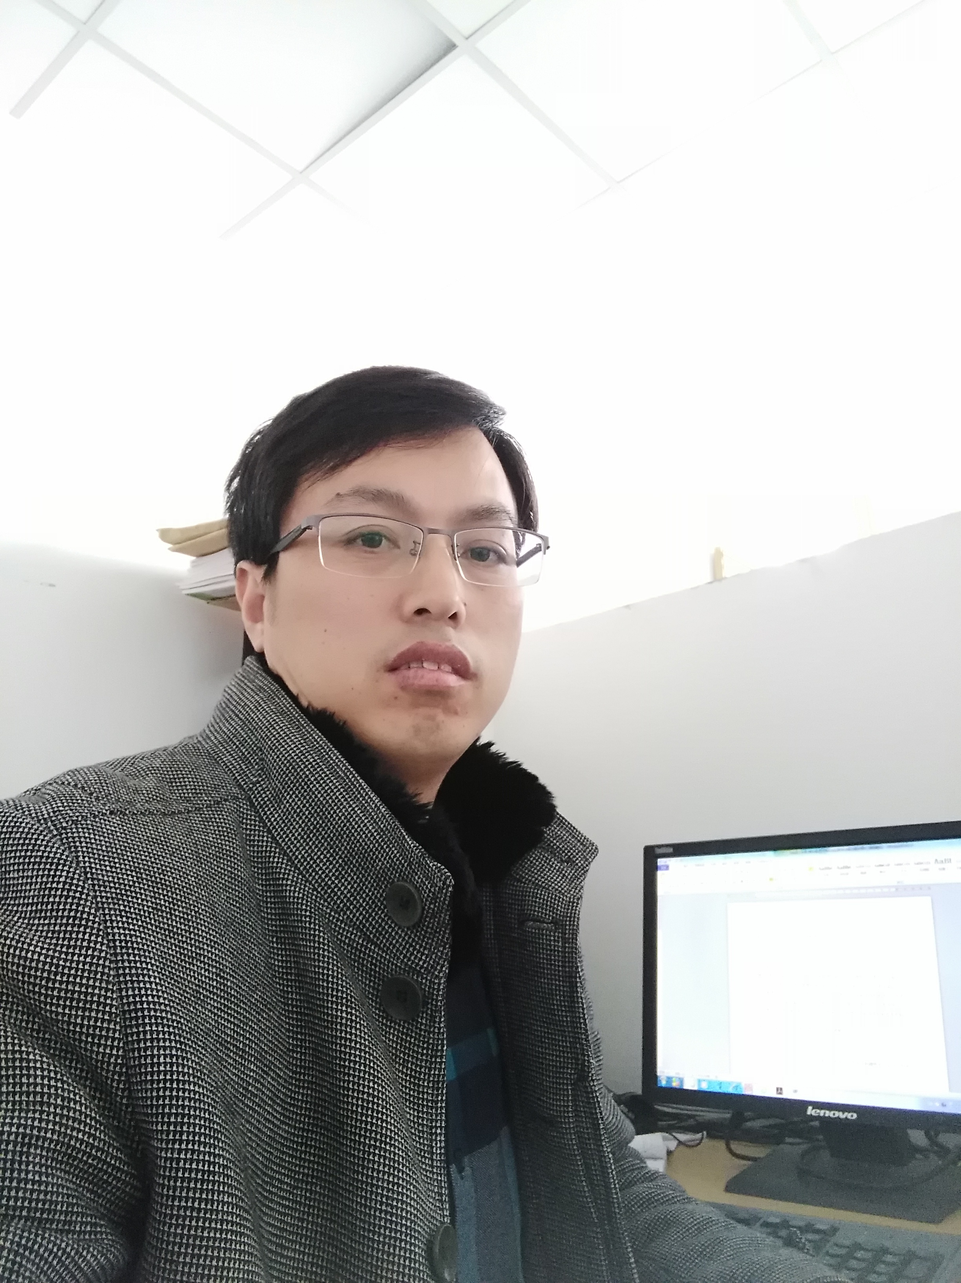

导师简介：
博士，教授，硕士生导师，职业环境毒理系副主任，长期致力于职业流行病学、工作场所心理社会因素与健康领域的研究。担任江苏省劳动卫生与职业病学会、工业毒理学学会委员，主持两项国家自然科学基金、2项省部级科研项目。发表学术论文60多篇，编写人民卫生出版社、科学出版社《职业卫生与职业医学》本科教材，学术专著《职业紧张评价与控制》。并获得四项省部级科研成果奖励。

研究方向：职业流行病学；工作场所心理社会因素与健康
荣誉获奖：先后获得吴执中医学奖三等奖、华夏医学科技奖三等奖、新疆维吾尔自治区科技进步奖二、三等奖三项。
主持在研项目：
1. 国家自然科学基金：环境与遗传因素相互作用对紧张反应易感性影响的研究；
2. 南通市科技项目：孕期慢性应激及早期环境干预对子代学习记忆能力影响机制研究；
3. 横向合作科研项目：慢性病社区诊断技术服务

已完成科研项目：
- 国家自然科学基金：环境与遗传因素相互作用对紧张反应易感性影响的研究。

近五年发表论文：
- Yulong Lian, Jing Xiao, Qian Wang, Li Ning, Suzhen Guan, Hua Ge, Fuye Li and Jiwen Liu. The relationship between glucocorticoid receptor polymorphisms, stressful life events, social support, and post-traumatic stress disorder. BMC Psychiatry. 2014,12;14:232.
- Yulong Lian, Jing Xiao, Yan Liu, Li Ning, Suzhen Guan, Hua Ge, Fuye Li, Jiwen Liu. Associations between insomnia, sleep duration and poor work ability. J Psychosom Res. 2015,78(1):45-51.
- Yulong Lian, Jing Xiao, Xiaoli Ji, Suzhen Guan, Hua Ge, Fuye Li, Li Ning, Jiwen Liu. Protracted low-dose radiation exposure and cataract in a cohort of Chinese industry radiographers. Occup Environ Med. 2015,72(9):640-7.
- Yulong Lian, Yiyang Gu, Rui Han, Yu Jiang, Suzhen Guan, Jing Xiao, Jiwen Liu. Effect of Changing Work Stressors and Coping Resources on Psychological Distress. J Occup Environ Med. 2016,58(7):e256-63.
- Yulong Lian, Jing Xiao, Chen Zhang, Suzhen Guan, Fuye Li, Hua Ge, Jiwen Liu.
A comparison of the relationships between psychosocial factors, occupational strain, and work ability among 4 ethnic teacher groups in China. Arch Environ Occup Health. 2016;71(2):85-101.
- Yu Jiang, Changyong Cui, Hua Ge, Suzhen Guan, Yulong Lian, Jiwen Liu. Effect of 5-HT2A receptor polymorphisms and occupational stress on self-reported sleep quality: a cross-sectional study in Xinjiang, China. Sleep Med. 2016,20:30-6.
- Guan Suzhen, Liu Jiwen, Fang Evandro Fei, Ng Tzi Bun, Lian Yulong, Ge Hua. Chronic unpredictable mild stress impairs erythrocyte immune function and changes T-lymphocyte subsets in a rat model of stress-induced depression. Environmental Toxicology and Pharmacology, 2014,37(1):414-422.
- Yulong Lian, Cong Qi, Ning Tao, Rui Han,Yu Jiang, Suzhen Guan, Hua Ge, Li Ning, Jing Xiao, Jiwen Liu. Changing work stressors and coping resources influence blood pressure and hypertension incidence in a large OHSPIW cohort. J Hum Hypertens, 2016, 00:1-7.（Epub）DOI: 10.1038/jhh.2016.79.
- Yulong Lian, Jing Xiao, Chen Zhang, Suzhen Guan, Fuye Li, Hua Ge, Jiwen Liu. comparison of the relationships between psychosocial factors, occupational strain, and work ability among 4 ethnic teacher groups in China. Arch Environ Occup Health. 2016,71(2):74-84.
10. Cong Qi, Yiyang Gu, Qing Sun, Hongliang Gu , Bo Xu, Qing Gu, Jing Xiao, and Yulong Lian. Low-dose N,N-Dimethylformamide exposure and liver injuries in a cohort of Chinese leather industry workers. JOEM, 2017,1-7. DOI: 10.1097/JOM.0000000000000983 （通讯作者）
11. Xiao J, Guan S, Ge H, Tao N, Zhang Y, Jiang Y, Ning L, Liu J, Lian Y. The impact of changes in work stressors and coping resources on the risk of new-onset suicide ideation among Chinese petroleum industry workers. J Psychiatr Res. 2016,88: 1-8. （通讯作者）
12. Jiang Y, Tang J, Li R, Zhao J, Song Z, Ge H, Lian Y, Liu J. Effect of 5-HT2A Receptor Polymorphisms, Work Stressors, and Social Support on Job Strain among Petroleum Workers in Xinjiang, China. Int J Environ Res Public Health. 2016,13(12). pii: E1258. （通讯作者）
发明专利：

1. 国家发明专利：一种用于检测毛发中皮质醇含量的前处理方法（ZL2013 1 0334157.3）

